# CSC242: ASSIGNMENT 1

Implement the functions below in the template file **[lastname]PA1.**py which can be found on [the D2L site](http://d2l.depaul.edu/) in the dropbox for the assignment.  Be sure to remove the ‘pass’ statements and change the docstrings as instructed. Submit the .py file to the submission box.

Functions submitted with syntax errors which prevent starting the function will receive 0 points. Runtime errors will result in 50% off the points for the function.

**PART 1: class transportcenter**

The class has 5 properties:

number of units coming in

number of units going out

current number of units

beginning number of units

number of spaces for units

The class transportcenter has 5 methods:

unitsIn:

takes number of units coming in

adds to number of units

unitsOut:

takes number of units going out

if greater than number of units then error

reduces number of units by number of units in parameter

unitsPrint:

prints number of units in and units out

unitsHere:

returns current number of units

unitCheck:

prints number of units in current number of units variable

prints number of units calculated from starting number of units

plus units in minus units out

See sample output for specifics

SAMPLE RUNS:

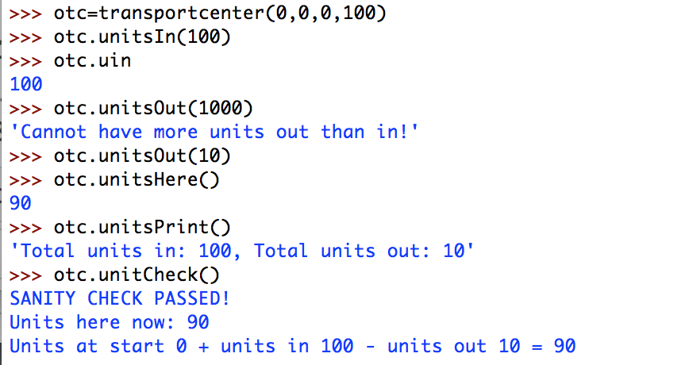

**PART 2: class airport**

airport is of type transportcenter

The class has 2 methods

addRunways

adds to number of runways

remRunways

removes from total number of runways

overloads unitsPrint

shows runways as well (see sample run)

SAMPLE RUNS:

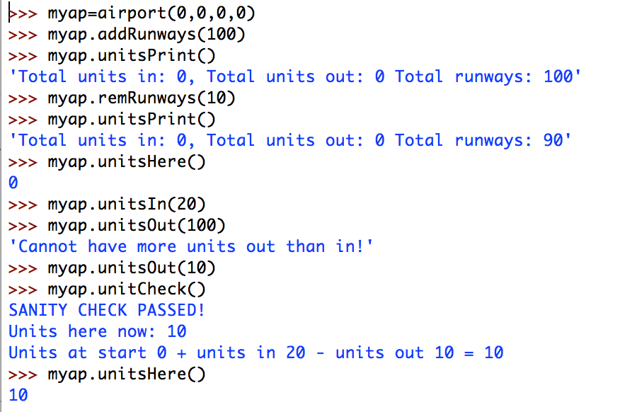

## Submitting the assignment

For full credit, check for the following before submitting:

1. your program file must be named [yourlastname]asg1.py
2. your name must be at the top of the file
3. all ‘pass’ statements must have been removed
4. your program must not have any syntax errors or runtime errors to get full credit
5. the functions must have identical names to those described in this assignment

**You must submit the .py file to the dropbox by the due date.**

Up to the due date, you can submit as many versions of your solution as you would like. The last file submitted is the one graded. The final file should contain solutions for all of the problems in the assignment. There will be no grading across submissions. Submissions must make the deadline or a zero is given for the assignment.

## Grading

You will only receive points if the code you submit runs without syntax errors.